Give that the statement chr(ord(alpha) + i) returns the character(alphabet or a special character) at the location i ahead than the  
    alphabet alpha, eg, chr(ord(’a’)+1) returns ‘b’; what is the output of the following code?  
  
 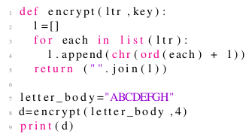

 ABCDEFGH

 BCDEFGHI

 EFGHIJKL

 none of the above

Yes, the answer is correct.  
Score: 1

Accepted Answers:

*BCDEFGHI*

***1 point***

What does the following code do?  
  
 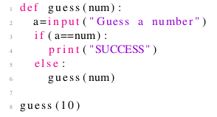

 Keeps asking the user to guess a number until the user guesses 10

 The computer generates a random number r and keeps it. The user is repeatedly prompted to enter a number. If the user enters r, the code says success and ends, else the prompting is continued.

 Enters an infinite loop

 The computer generates a random number r and keeps it. The user is repeatedly prompted to enter a number. If the user enters r, the code says success and ends, else the computer generates a new random number r and thereafter the prompting is continued.

Yes, the answer is correct.  
Score: 1

Accepted Answers:

*Enters an infinite loop*

***1 point***

What does the following code do?  
  
 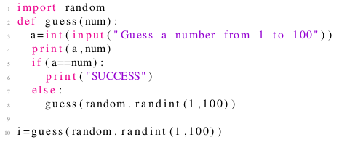

 Keeps asking the user to guess a number until the user guesses 10

 The computer generates a random number r and keeps it. The user is repeatedly prompted to enter a number. If the user enters r, the code says success and ends, else the prompting is continued.

 Enters an infinite loop

 The computer generates a random number r and keeps it. The user is repeatedly prompted to enter a number. If the user enters r, the code says success and ends, else the computer generates a new random number r and thereafter the prompting is continued.

Yes, the answer is correct.  
Score: 1

Accepted Answers:

*The computer generates a random number r and keeps it. The user is repeatedly prompted to enter a number. If the user enters r, the code says success and ends, else the computer generates a new random number r and thereafter the prompting is continued.*

***1 point***

With n as input, the code below computes  
  
 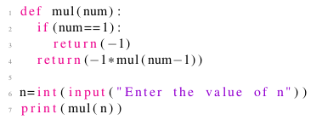

 −1 × n

 −1 + n

 (−1)n

 n(−1)

Yes, the answer is correct.  
Score: 1

Accepted Answers:

*(−1)n*

***1 point***

The following code  
  
 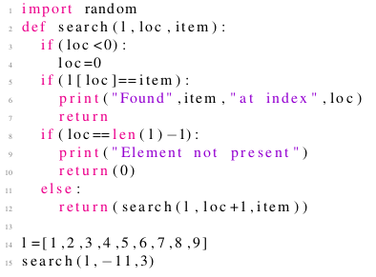

 displays an error

 does not display an error but might display the error if we change the middle value passed in the function search() from 0 to some negative value.

 Can return a negative value in some cases when we change the values passed to the function search()

 Scans the list from first to the last element and displays the index of the value passed in the last number in the function search().

Yes, the answer is correct.  
Score: 1

Accepted Answers:

*Scans the list from first to the last element and displays the index of the value passed in the last number in the function search().*

***1 point***

The following code represents  
  
   
 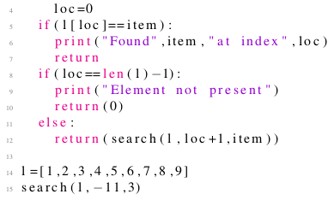

 recursive algorithm for linear search an element in a list

 recursive algorithm for binary search an element in a list

 non-recursive algorithm for linear search an element in a list

 none of the above

Yes, the answer is correct.  
Score: 1

Accepted Answers:

*recursive algorithm for linear search an element in a list*

***1 point***

What is the output of print(int(3.79)+int(2.1))?

 6

 5

 7

 4

Yes, the answer is correct.  
Score: 1

Accepted Answers:

*5*

***1 point***

The following code to its best, represents a scenario  
  
 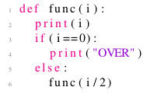

 A cake getting eaten by half of its current amount every time

 A student attempting alternate questions, starting from a given question

 Viruses doubling inside a body and killing the person once their population becomes 128 or more.

 Metro train serving 128 stations to and fro

Yes, the answer is correct.  
Score: 1

Accepted Answers:

*A cake getting eaten by half of its current amount every time*

***1 point***

The following code to its best, represents a scenario  
  
 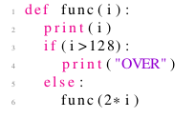

 A cake getting eaten by half of its current amount every time

 A student attempting alternate questions, starting from a given question

 Viruses doubling inside a body and killing the person once their population becomes 128 or more.

 Metro train serving 128 stations to and fro

Yes, the answer is correct.  
Score: 1

Accepted Answers:

*Viruses doubling inside a body and killing the person once their population becomes 128 or more.*

***1 point***

The following code to its best, represents a scenario  
  
 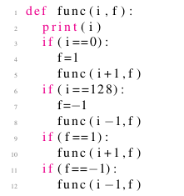

 A cake getting eaten by half of its current amount every time

 A student attempting alternate questions, starting from a given question

 Viruses doubling inside a body and killing the person once their population becomes 128 or more.

 Metro train serving 128 stations to and fro

Yes, the answer is correct.  
Score: 1

Accepted Answers:

*Metro train serving 128 stations to and fro*